The Unlikeliest of Heroes
By Mike Serviss
Most of us enjoy access to a wide variety of delicious foods. We browse the produce aisles of the local grocery store and find edibles from all over the world. The mangos, lemons, strawberries and kiwis alike all shout out for attention from their displays. We squeeze the fruits to make sure they are ripe, smell them for freshness and carefully inspect them for blemishes. The nuts tempt us with their sweet and salty personalities while the vegetables just hope that kids will like them. We expect that our options will be plentiful each time we visit the store, but what if that were to change?

Many researchers believe our supply of phosphorus, a natural ingredient in many fertilizers which help crops grow, will run out within the next 100 years. While that is a scary thought, fear not for our food! The most unlikely of heroes may help keep our grocery store displays full of delicious options. The pecan truffle, a fungus which grows under the ground, may be the key to solving our future fertilizer crisis and helping the world grow food sustainably. SUNY-ESF graduate student Dale Warner researches the truffle and its potential role in replacing fertilizers.
What is a truffle?
A truffle is a type of fungus which grows underground. Many truffles are mycorrhizal, meaning that they form beneficial relationships with the roots of plants. Many truffles are also considered delicacies and are therefore very costly.

How do truffles help crops grow?

Truffles, in essence, act to enhance the root system of nearby plants. Plants and trees require nutrients from the soil in addition to sunlight and water. Soil nutrients generally exist in forms which plants are unable to use. Think of this like a bottle full of frozen water. You need the water, but are unable to drink it in its current form. This is where the truffle comes in. The truffle breaks nutrients down into usable forms and provides the nutrients to the plant. Also, the truffle helps to transport additional water to the roots of the plant through its own root-like system. Ever use a stick to help you reach something? You are the plant and the truffle is the stick in this situation. The truffle helps the plant reach water and nutrients which its own roots cannot reach. All of this helps the plant to grow taller faster. The truffle, meanwhile, obtains energy from the plant which gets its energy from the sun.
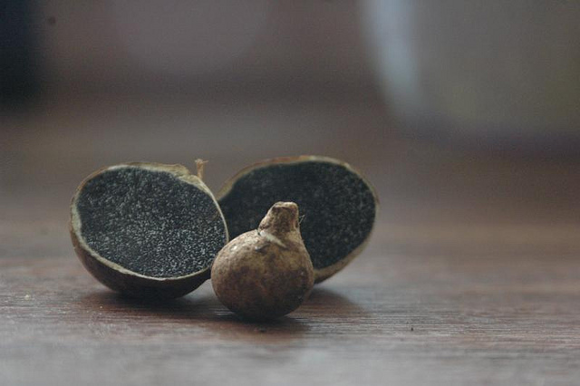
Why don’t we give all plants truffles?

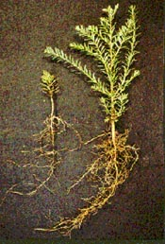
While truffles and other similar fungi help crops grow, they are not always available to the crops. Also, it is difficult to cultivate fungi for commercial application to crop fields. Dale Warner is attempting to find the most effective way to provide plant roots with truffle spores. His research centers on testing a possible association between the pecan truffle and the endangered American chestnut tree. Dale first sanitizes the truffles by dipping them in ethanol and setting them on fire. I know, science is so cool sometimes. He then puts them in a blender a makes something of a truffle smoothie. While that may not sound appetizing to most of us, Dale hopes that the chestnut seedlings feel otherwise. He then provides the truffle smoothie to the seedlings in two different manners. The first method involves removing the seedling from the soil and dipping the bare roots directly into the truffle mix and then replanting the seedling. The second method involves pouring the truffle drink directly into the soil around the seedling. Dale’s preliminary data suggests that the spores have colonized the tree roots and trees with truffle spores grow taller faster than trees treated with regular fertilizer. It almost seems as if he gave the trees a magical pill which makes them grow taller!
The pecan truffle commonly associates with pecan trees in the southeastern US.
http://theadventurebite.com/pecan-truffles-the-story-of-the-disappointing-delicacy/
Photo credit: Mike Amaranthus, USDA
Redwood seedlings with (right) and without (left) beneficial fungal associations.

A world without fertilizers?

Well, the world will almost certainly use fertilizers in one form or another. Although, a looming phosphate-based fertilizer shortage does provide incentive to find alternatives if we want to keep our delicious fruits and veggies regularly in stock. Dale believes that truffles and similar fungi can be used as alternatives to fertilizers if techniques for application are perfected. He hopes that crop yields will increase to meet the demands of a growing human population. If Dale’s hopes prove true, we would all owe a debt to the unlikeliest of heroes, the pecan truffle.

